MARKETING AUTOMATION
This module helps users to manage marketing processes and campaigns automatically. Using the correct workflow users can implement a digital marketing strategy without having to manually press ‘send’ on each and every email, message or campaign. Good automation helps to identify the audience and automatically trigger actions based on schedules and customer behavior. achieve the marketing process automated.

Views

The Marketing Automation module is available in two different views
- Kanban View
- List View

By default, it shows the Kanban view.

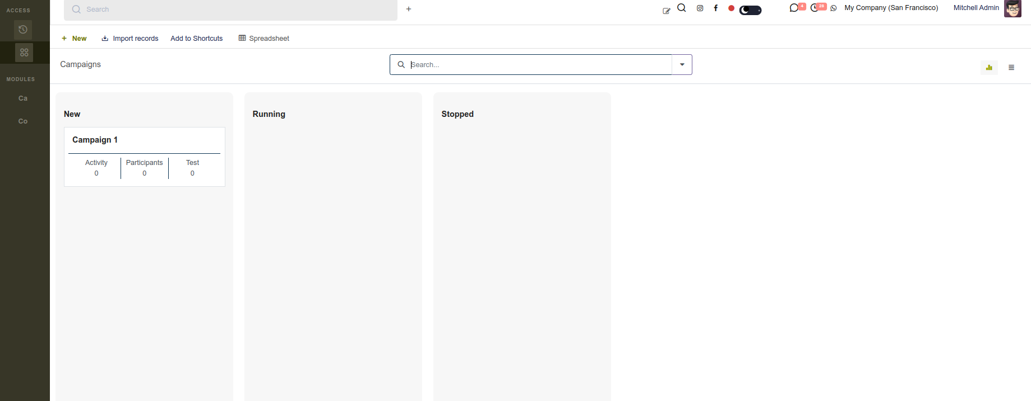

In the Kanban, it is easy to identify each campaign in the corresponding states. Also, we can identify each number of Activities, Participants, and Test Participants in each campaign from the Kanban view.

Similarly, In the Tree view, each Campaign record can be found alongside the Target Module and its current State. The state of each Campaign is indicated by different colors for easy recognition. Additionally, the responsible person is available as an optional field in the tree view.
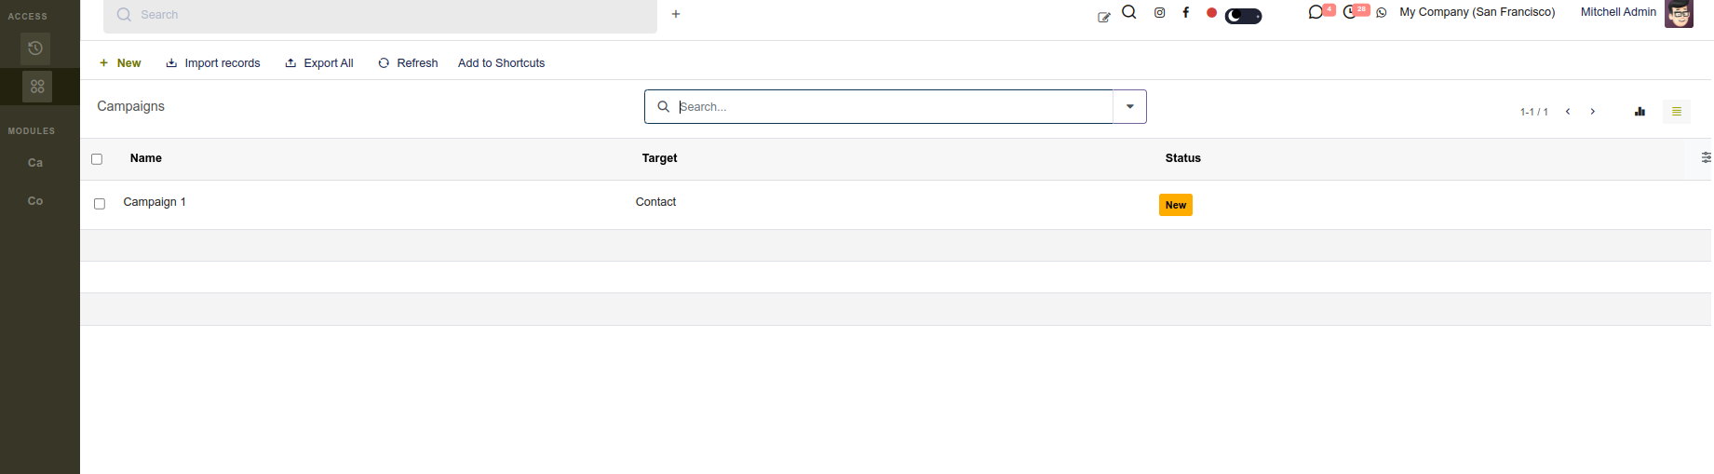

Marketing Campaign Setup

To create new Campaigns in Marketing Automation. Navigate to the New button available in the Top of the view

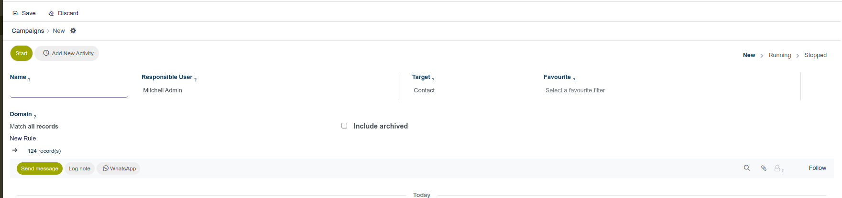

By clicking on the New button a form view will appear to create new campaigns. Firstly you can provide a name for the campaigns and it is a mandatory field. After that, there is an option to select the Target module from the target field. This field is also a required field. This Target field determines to whom this marketing automation campaign should be sent. There is also a field called Favourites available to select the pre-defined domain for the Target module.

You can create the favorites filter from Configuration -> Favourites

On clicking on the Favourites menu a new List view will be opened.
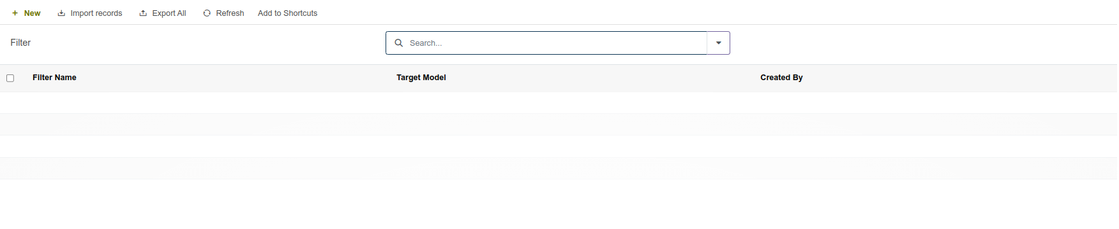
You can click on the “New” Button to create a new favorite record.

Add a filter name and choose a target Model for the record. After choosing the target model you can choose the domain for that selected target model and save the record.
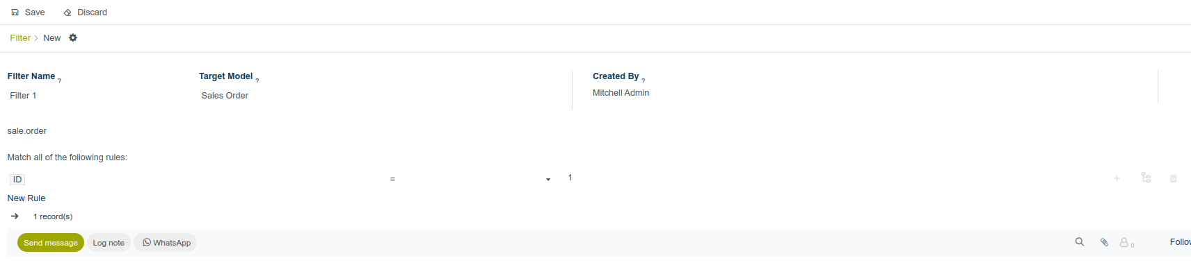

Go back to the Campaigns form view to select the created Favourites filter.
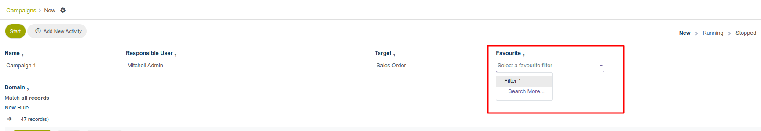

The Domain field in the campaign form assists in filtering the number of records from the target model to determine which participants will participate in the campaign.
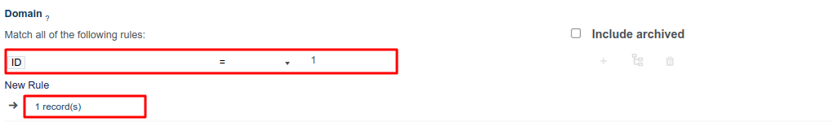

We can track the Status of each campaign whether it is New, Running, or Stopped from the top right corner of the form view.
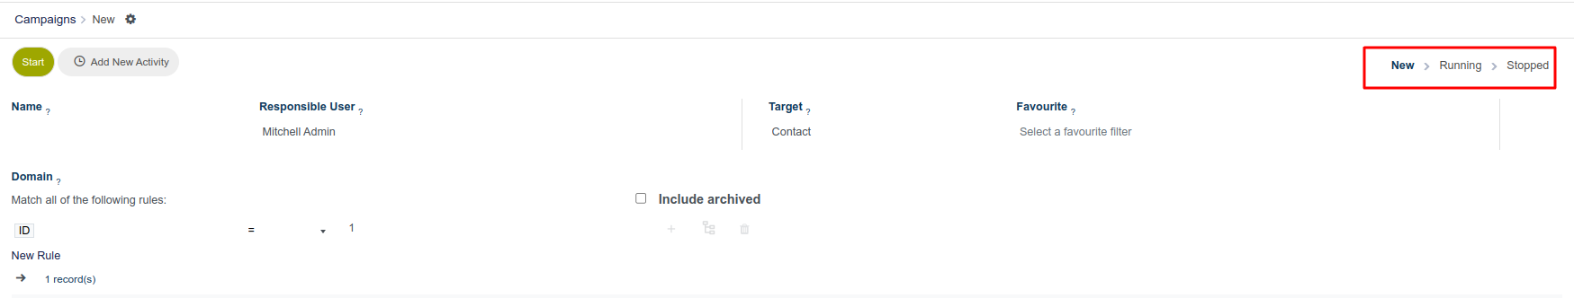

After filling in all the fields, next you can add the activities that need to be performed in the campaign. You can add new activities by clicking on the “Add New Activity” button at the top of the view.
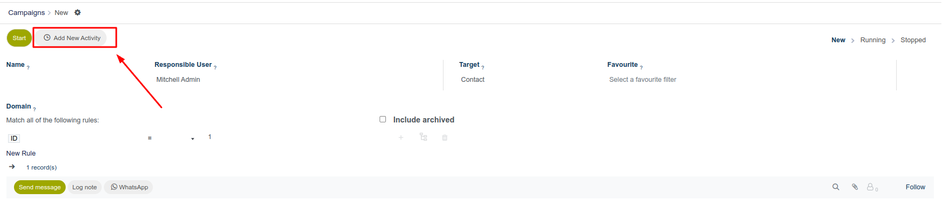

This will redirect to a new window. From the new window, you can add the activities for a campaign.

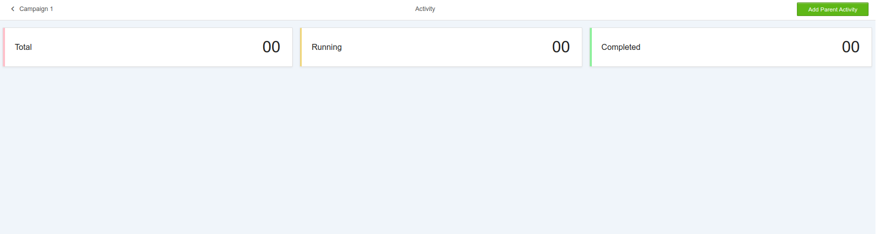

Click on the “Add Parent Activity” button to create a parent activity for the campaign. On clicking the button a new pop-up window will appear to add the new activity.

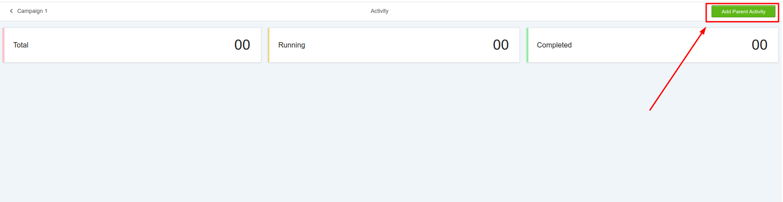

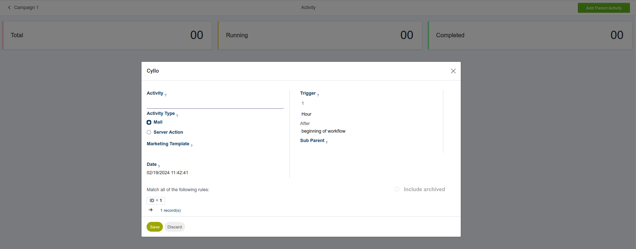

Begin by providing a name for the activity within the designated "Activity " field. Subsequently, proceed to adjust the following options as needed.

Activity Type

There are two kinds of activity types available which are Mail and Server action. This activity type will decide the action that needs to be performed for each activity in a campaign.

- Mail
If Mail is the activity that you chose, then it is mandatory to select an email template to send the emails. You can choose the mail template from the Marketing template field.
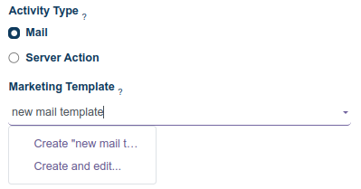
Provide a name for the email template and click on the create and edit option. By clicking on it a new pop-up will appear. In that pop-up window, you can choose the template body that you need to send for the emails
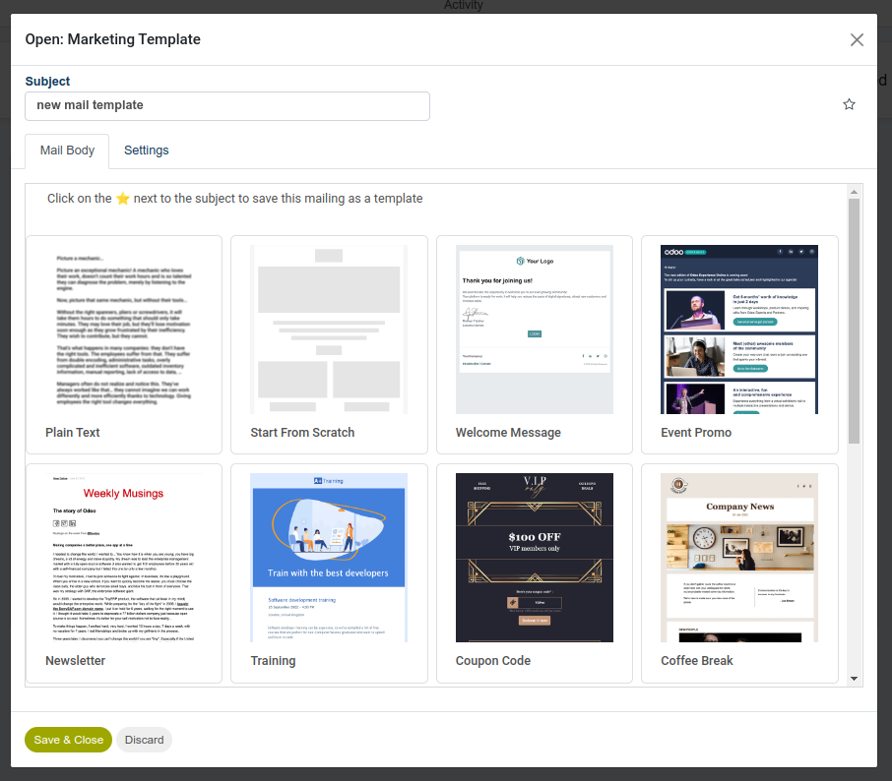
- Server Action
If Server Action is the activity that you chose, then it is mandatory to select an Action to perform an internal action within the database. You can set the action from the Server Action field.
You have the option to select the already available server actions or you can create a new server action.
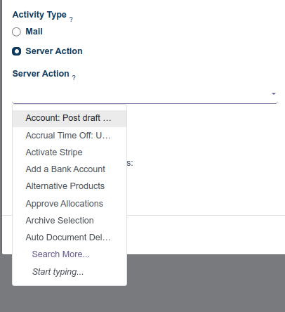
The above are the pre-configured server actions and you can click on “search more “ to see all the actions.
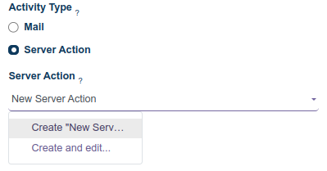
To create new actions, you can add a name for the action and click on “Create and edit”. It will open a new pop-up window for the server action.
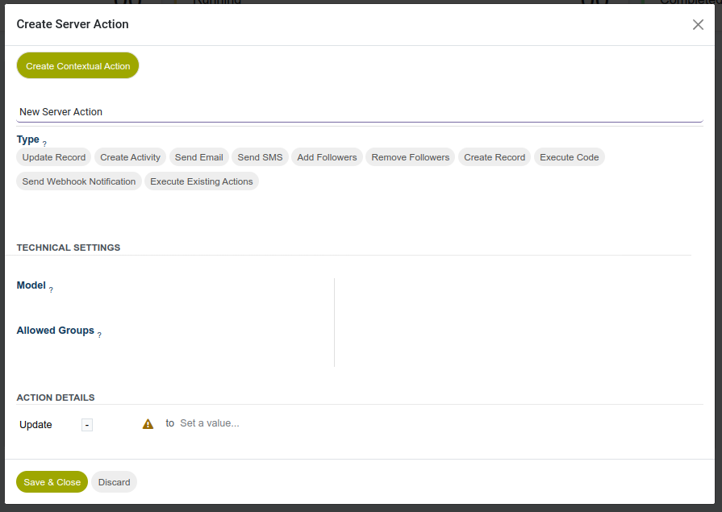

Trigger

Users can utilize the Trigger field to select the specific timing for when the designated workflow activity should be initiated.

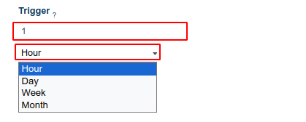

The first field is an integer field where you can provide integer values, representing the number of time gaps. In the subsequent selection field, you can choose when the activity should be triggered; options include Hour, Day, Week, or Month.

Next, click on the last field, labeled "Beginning of the workflow by default," to reveal a dropdown menu containing additional trigger options.

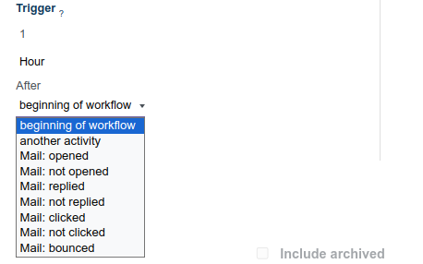

The trigger options are as follows:

- beginning of the workflow: the activity will be triggered at the previously configured time after the beginning of the entire workflow.
- another activity: the activity will be triggered at the previously configured time after another specific activity in the workflow.
- Mail:opened: the activity will be triggered at the previously configured time if the sent mail in the workflow has been opened by the recipient.
- Mail: not opened: the activity will be triggered at the previously configured time if the sent mail in the workflow has not been opened by the recipient.
- Mail: replied: the activity will be triggered at the previously configured time if the sent mail in the workflow has been replied to by the recipient.
- Mail: not replied: the activity will be triggered at the previously configured time if the sent mail in the workflow has not been replied to by the recipient.
- Mail: clicked: the activity will be triggered at the previously-configured time if the sent mail in the workflow has been clicked by the recipient after it’s been opened.
- Mail: not clicked: the activity will be triggered at the previously-configured time if the sent mail in the workflow has not been clicked by the recipient after it’s been opened.
- Mail: bounced: the activity will be triggered at the previously configured time if the sent mail in the workflow has been bounced back for any reason.

After creating and saving an activity, it will appear as an activity card as a new tab.

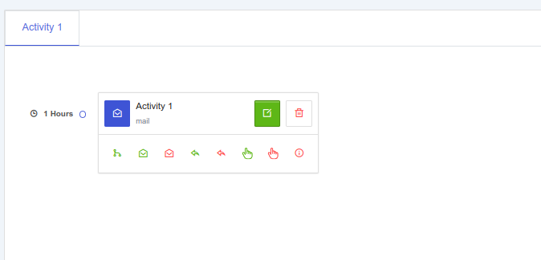

Within each activity, you can view the trigger time associated with it. Additionally, you have the option to add child activities to each parent activity by clicking on various buttons located within the activity card.

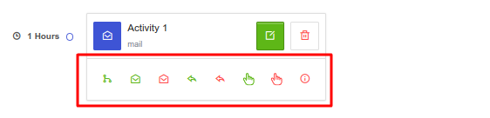

There are a variety of triggering options to initiate a child activity, all of which are contingent on the trigger configurations associated with its parent activity. These options can be accessed under the desired parent activity.

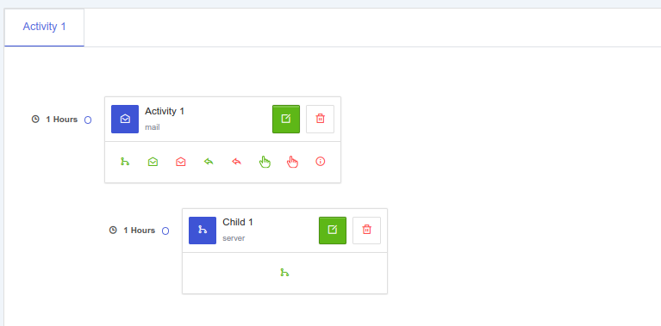

Test Campaigns

The Marketing Automation app enables users to test marketing campaigns before officially launching them, allowing for error checking and correction of any mistakes prior to reaching the target audience.

To test the campaign you can click on the button “Launch Test” in the top right corner. This button will only be visible if there is at least one activity is present in the campaign

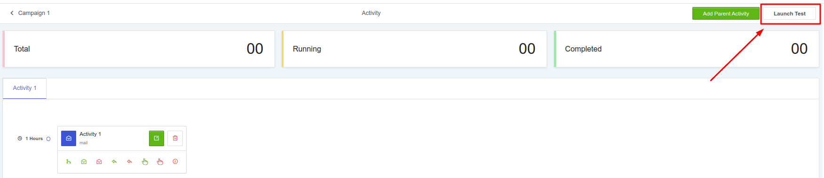

On clicking the button a new drop-down will appear.

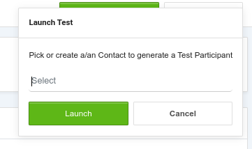

Select a contact to launch a test or you have the option to create a new contact from here itself.

After selecting a contact click on the Launch button in the drop-down
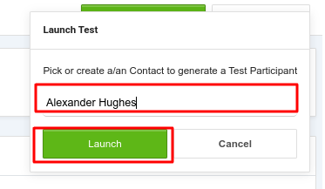
On clicking the button a new window will be opened with the test records. There will be a ribbon in the view to identify the test record

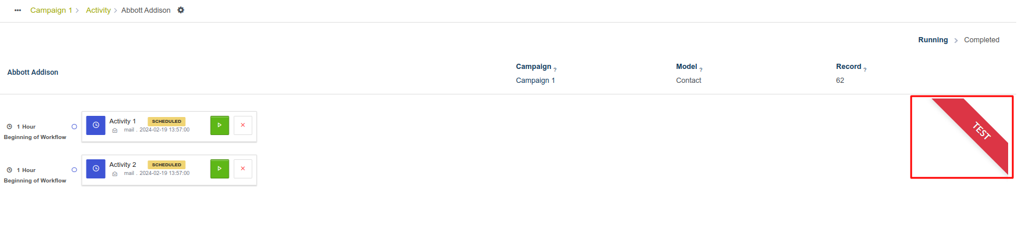

To initiate a test, click on the Run button, which is denoted by a ▶️ (play button) icon located next to the first activity in the workflow.

After running each activity, the status of the corresponding activities will be updated, and any associated child activities will become visible if they exist.
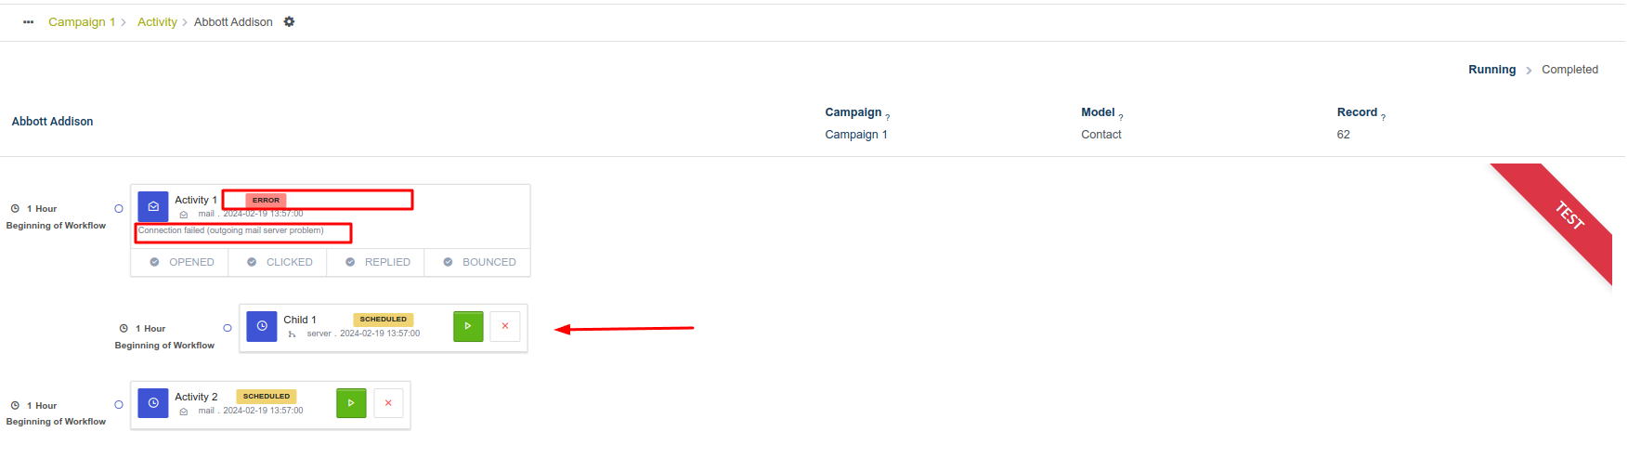

Once all activities are completed, the test concludes, and the status bar in the upper-right corner moves to the Completed stage.

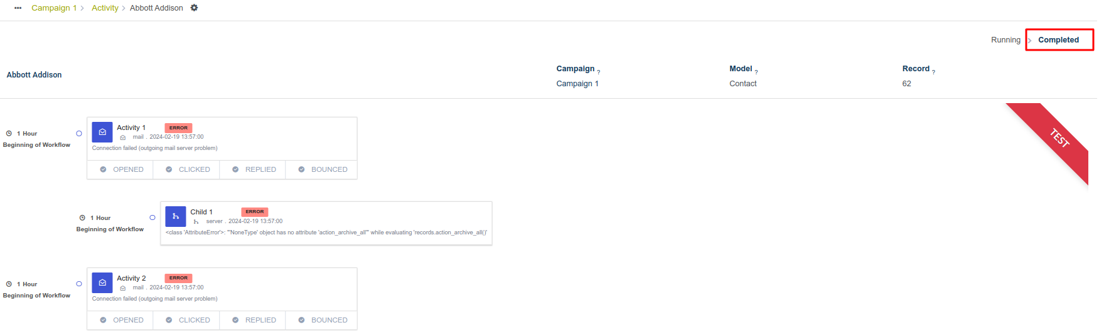

Run Campaigns

To run the campaigns open the form view of the campaign page, and click on the “Start” button on the top left corner of the form view.

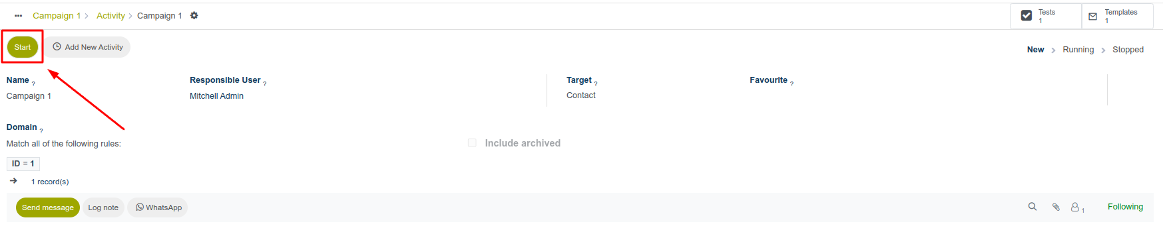

On clicking this button the campaign launches and the status of the campaign moves to the running state
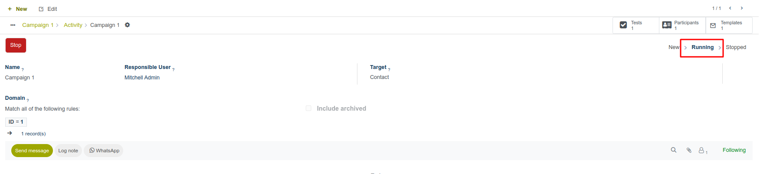

You can track test campaigns, participants in those campaigns, and templates used in those campaigns from the smart button inside the corresponding campaigns.

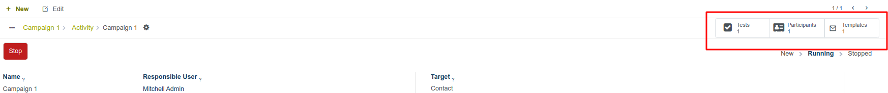

Stop Campaign

To stop the campaigns open the form view of the campaign page, and click on the “Stop” button on the top left corner of the form view.

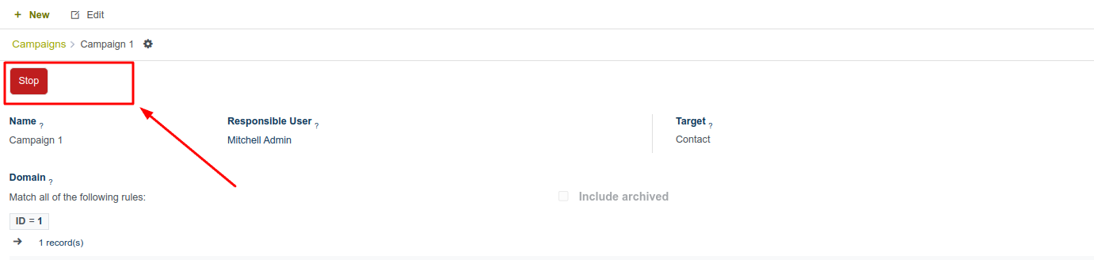

On clicking this button the campaign moves to the stopped state.

